# CS 255 System Design Document Template

This template lays out all the different sections that you need to complete for Project Two. Each section has guidance to prompt your thinking. You will need to continually reference the interview transcript as you work to make sure that you are addressing your client’s needs. There is no required length for the final document. Instead the goal is to complete each section based on what your client’s needs are. Remove this note when you are finished, and replace all bracketed text with the relevant information.

## UML Diagrams

### UML Use Case Diagram

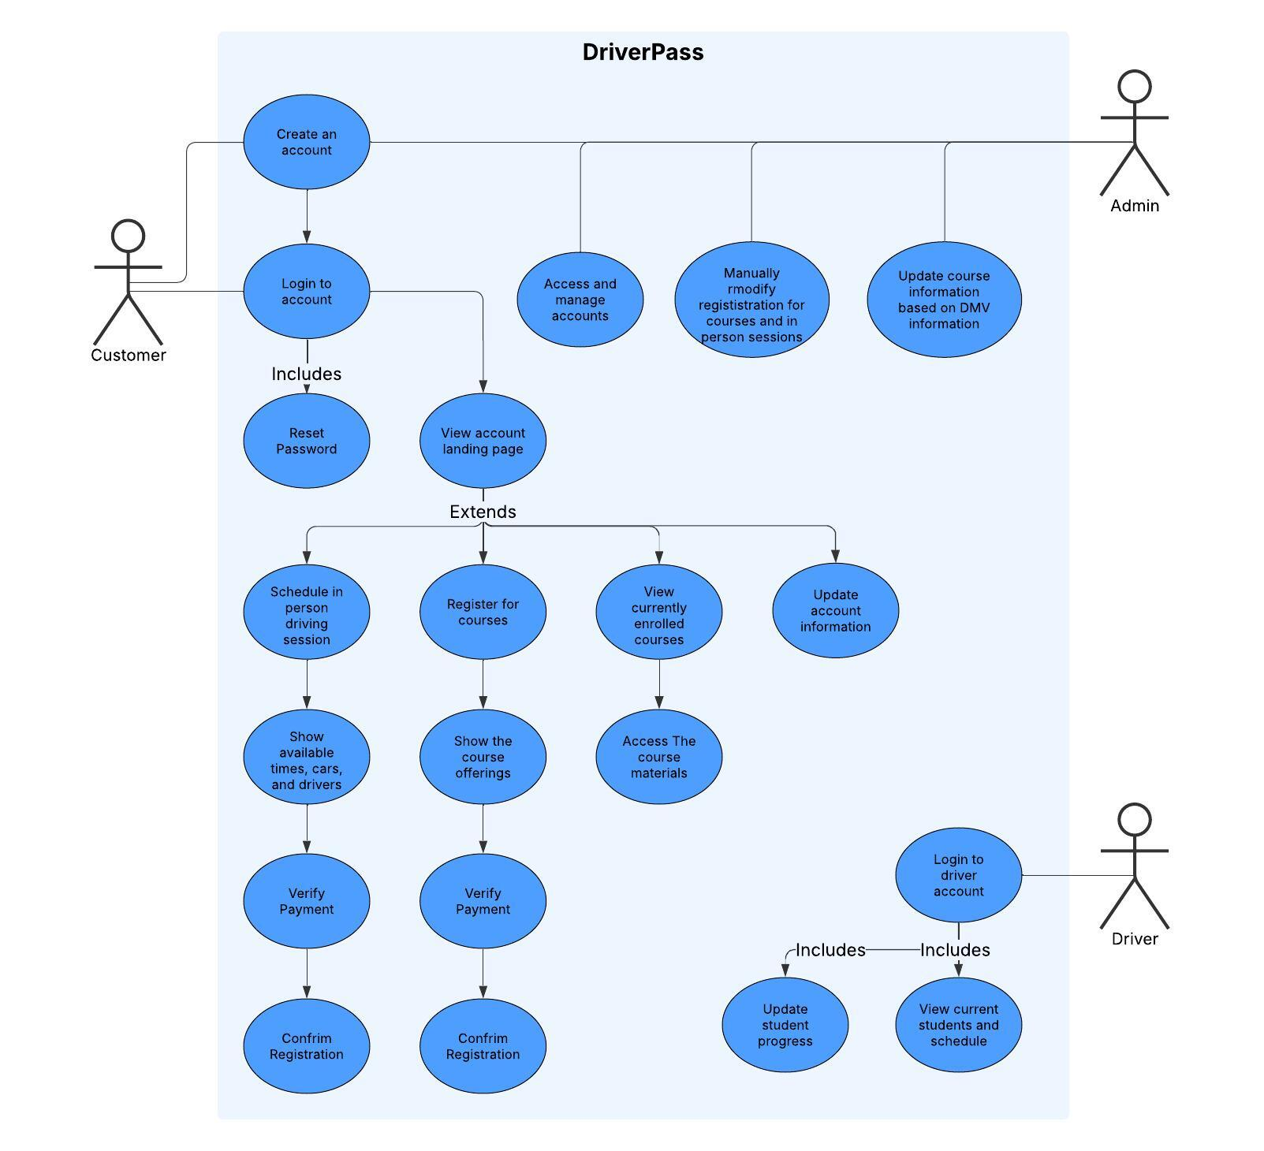

### UML Activity Diagrams

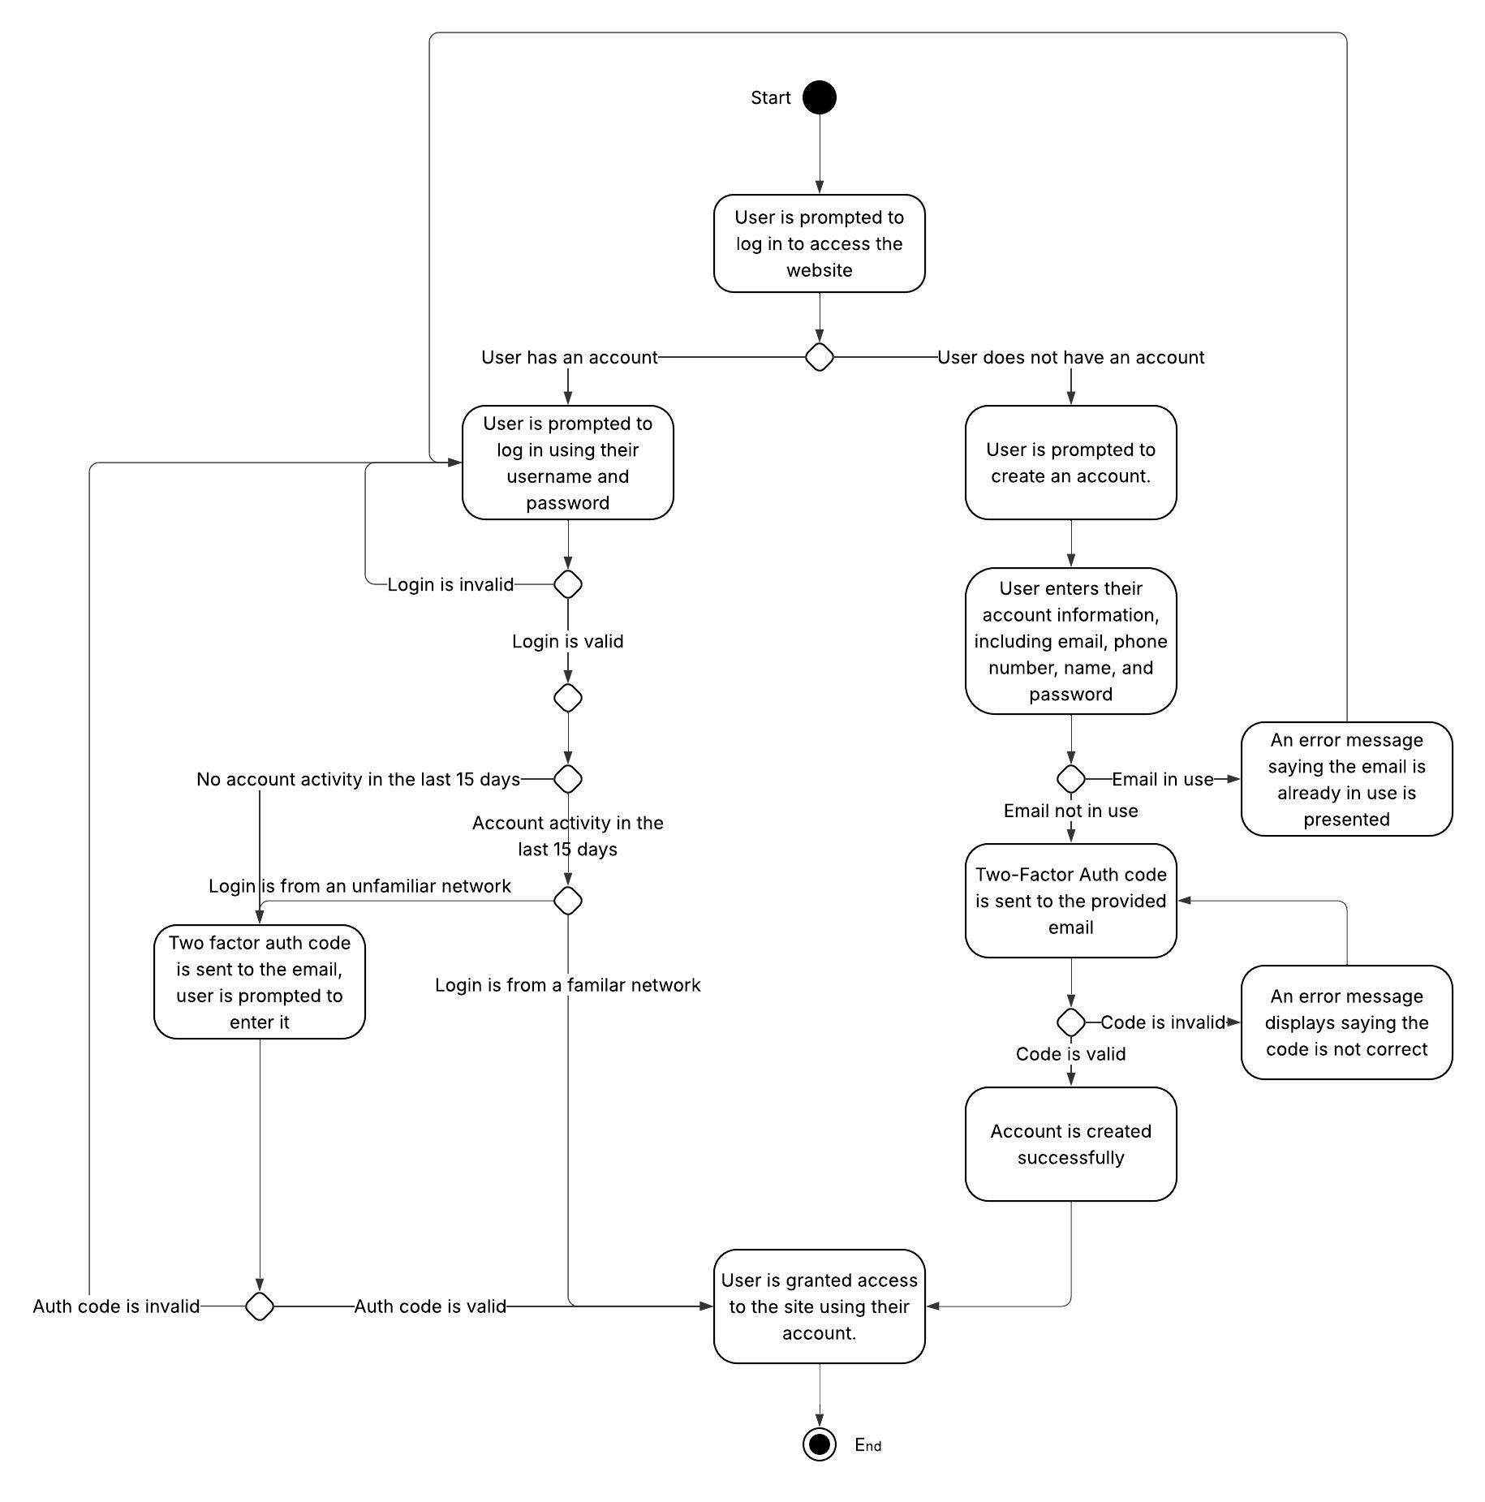

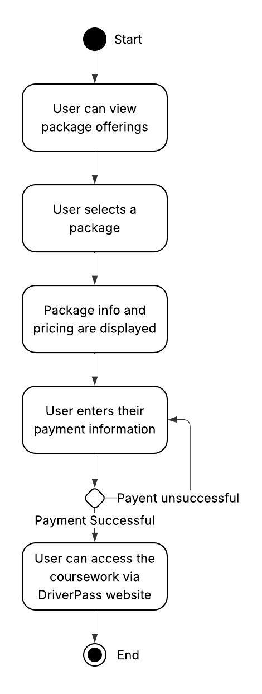

### UML Sequence Diagram

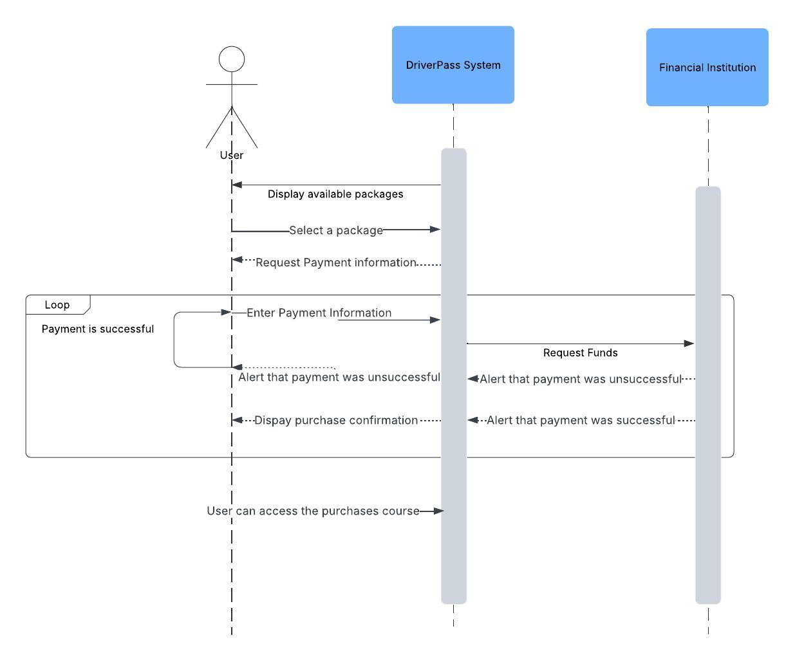

### UML Class Diagram

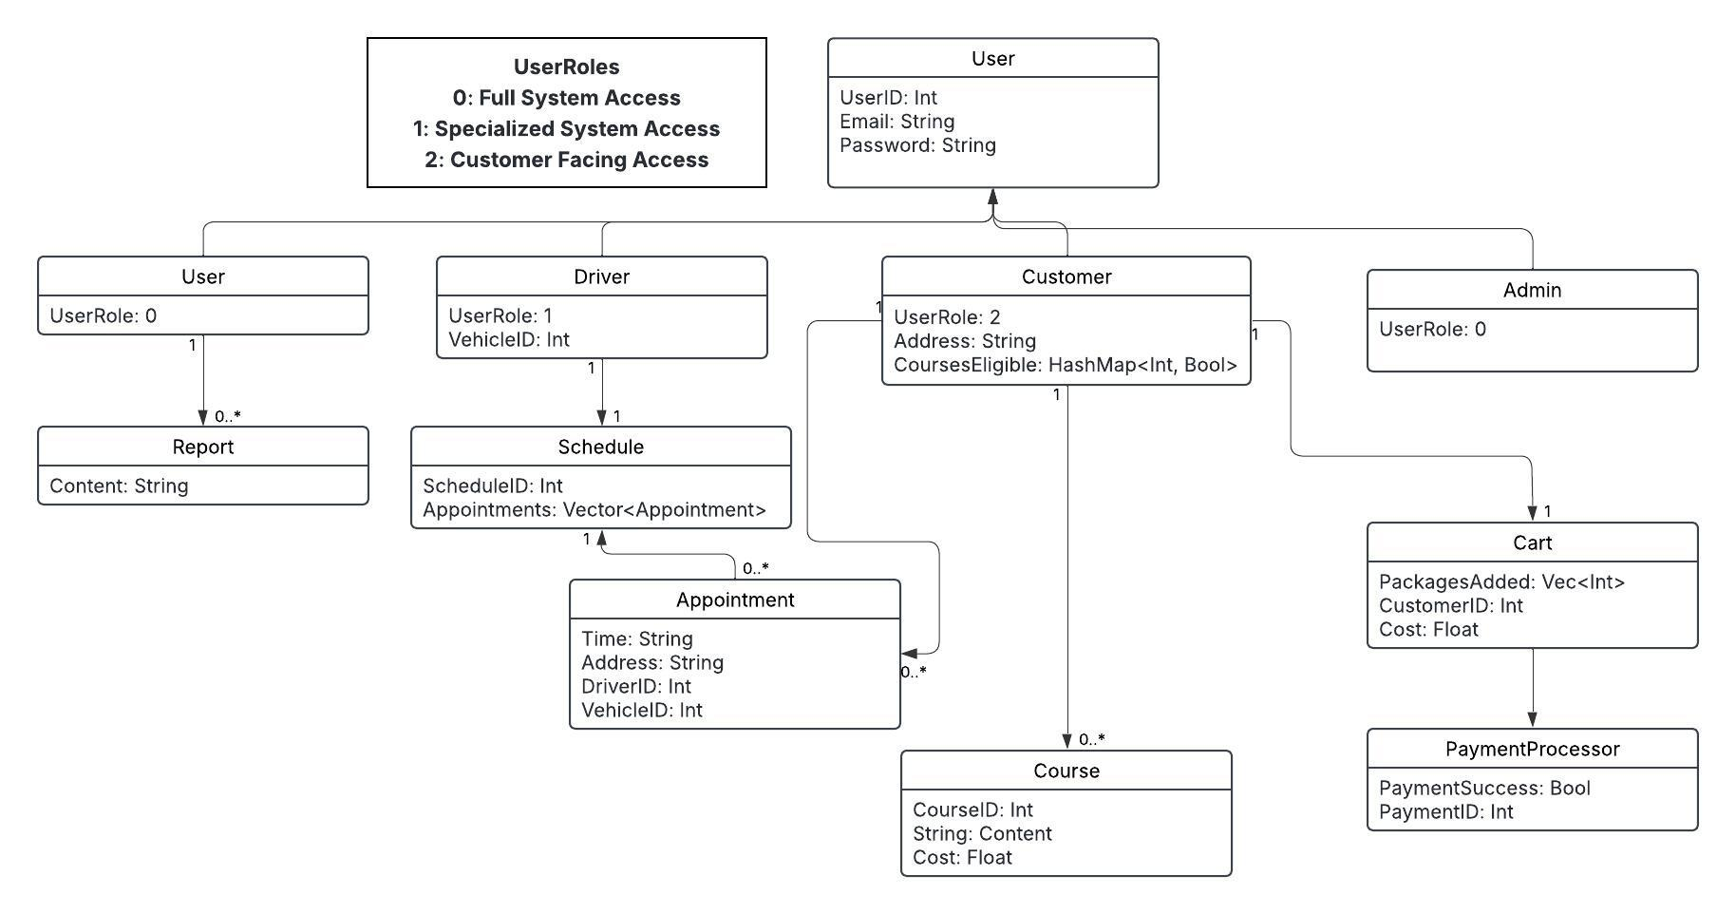

## Technical Requirements

The system will utilize AWS for the many security, management, and maintenance features that their services provide out of the box.

AWS pay per use model ensures that the system will have access to adequate storage for data and system resources.

The system will run seamlessly on Chrome, Safari, Edge, and FireFox browsers, as these are the most popular browsers.

Users will be encouraged to access DriverPass with a computer that has at least 8 gbs of RAM to ensure the website runs smoothly.

SQL will be utilized for databases.

The system will host backup databases to ensure data integrity.

Security is a primary concern, two factor authentication and clear communication from DriverPass will mitigate social engineering attempts.

The system will utilize standard TPS and HTTP connections to ensure a secure connection.

Dedicated monitoring of AWS services will provide admins with any security alerts.

Despite the many features offered by AWS already, a secondary firewall will be implemented for website security.